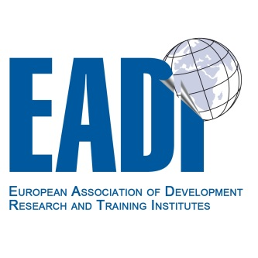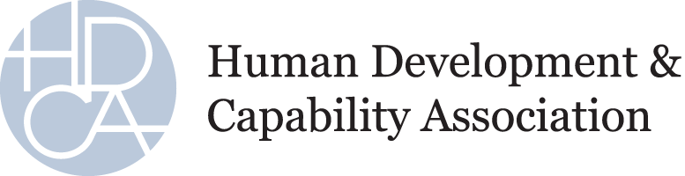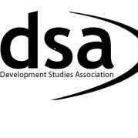
Call for Papers
Rethinking Development Research
The post-2015 development agenda and sustainable development goals
EADI/DSA Multidimensional Poverty Working Group, EADI Disasters and Development Working Group and HDCA Sustainable Human Development Thematic Group
25 - 26 June 2015, University Square Stratford, Centre for Social Justice and Change, University of East London, UK
2015 will see an assessment of how well we have done in achieving the Millennium Development Goals (MDGs) and a definition of the Post-2015 agenda. Currently this includes a reformulation of the MDGs and the introduction of Sustainable Development Goals (SDGs), which will no doubt, at least rhetorically, come to define the international agenda, affect aid and research funding. At present the proposed goals are listed on http://sustainabledevelopment.un.org/focussdgs.html, however, their number and how they are measured may change before adoption, which presents its own challenges.
Whilst some goals are familiar, the SDGs bring onto the agenda many issues with which development specialists do not normally engage especially those relating directly to the environment. The current MDGs have been criticized on many grounds amongst which has been the interconnected nature of these goals. This poses a challenge as policy makers, politicians, NGOs and academics tend to work in one area and pay (much) less attention to others.
We are pleased to announce this workshop encouraging researchers to reflect on how their own work can contribute to: (a) a better understanding of which goals to include in the post-2015 development agenda; (b) a better explanation on how one or more of the SDGs can be more effectively achieved; and (c) a critical exploration of what roles different development actors can play in achieving one or more of these goals. We seek to explore questions such as: Are the goals relevant and to whom? How should we engage with them as academics and as researchers wanting to do good research and have our voices heard?
Authors are invited to submit abstracts for papers which will outline their current work and relate it to the SDGs. The workshop and papers are meant as spaces for reflection rather than highly polished final versions though they too are welcome. The workshop is open to researchers, practitioners, students and academics, from across disciplines and areas of work.
Location: University Square Stratford, Centre for Social Justice and Change, University of East London,
Timing: 25 June (all day) and 26 June (morning)
Deadlines:
Deadline for abstracts (500 words): Monday 16th March
Notification of acceptance: Friday 17th April

Deadline for papers: Monday June 1st

Costs: The Workshop will be free, but participants have to pay for their meals and accommodation.

Abstract to:
EADI/DSA Multidimensional Poverty Working Group:
Dr Laura Camfield, Senior Lecturer in International Development, School of International Development, University of East Anglia, L.Camfield@uea.ac.uk
EADI Disasters and Development Working Group and HDCA Sustainable Human Development Thematic Group:
Andrew Crabtree, Adjunct Associate Professor, Dept. of Intercultural Communication and Management, Copenhagen Business School, Porcelænshaven 18A, 2000 Frederiksberg, Denmark
ac.ikl@cbs.dk

